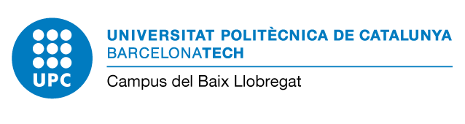
Edifici D7 - C/Esteve Terradas, 10
08860 Castelldefels (Barcelona)
Campus Baix Llobregat - Parc Mediterrani de la Tecnologia

Form for Authorization of a third party

Requester

Full name ID number/Passport number Telephone E‐mail address

Authorized person

Full name ID number/Passport number Telephone E‐mail address

Reason about the authorization

Pick up of the academic certificates Apply for the enrolment
Process and pick up the receipt of the title

Pick up the “Conveni de Cooperació Educativa” (the internship)

Others 1 : Signature of the requester: Signature of the authorized:

Full name Full name Place and date:
I am aware of the basic information about data protection presented at the back of this document that I have read.

Necessary documentation:

- Photocopy of the current ID or Passport of the requester
- Original document of the current ID or Passport of the authorized person
- This form filled in and signed

1 It is compulsory to indicate the reason for the authorization

1/2

Information about data protection
Responsible of data processing | Universitat Politècnica de Catalunya  Campus del Baix Llobregat  https://cbl.upc.edu/ca  cbl.proteccio.dades@upc.edu
Contact details of the data protection officer | Universitat Politècnica de Catalunya  https://www.upc.edu/normatives/ca/proteccio-de-dades/normativa-europea-de-proteccio-de-dades/dades-de-contacte-del-delegat-de-proteccio-de-dades
Purposes of data treatment | F01.4 Admissió, matrícula, avaluació i gestió de l’expedient acadèmic dels estudiants  https://rat.upc.edu/ca/registre-de-tractaments-de-dades-personals/F01.4  Process Baix Lleobregat Campus’ students’ applications for third parties permissions
Laws of data processing: | (Exercici de poders públics)  Processing is necessary for the performance of a task carried out in the public interest or in the exercise of official authority vested in the controller  https://www.upc.edu/normatives/ca/proteccio-de-dades/normativa-europea-de-proteccio-de-dades/legitimacio
Transfer of personal data to third parties | Your data will not be communicated to third parties, unless there was a legal obligation.
Data subject’s rights | (Sol·licitar l’accés. La rectificació o supressió. La limitació del tractament. Oposar-se al tractament. Portabilitat de les dades.)  Right of access by the data subject, Right to rectification, Right to erasure (‘right to be forgotten’), Right to restriction of processin, Right to data portability  https://www.upc.edu/normatives/ca/proteccio-de-dades/normativa-europea-de-proteccio-de-dades/drets
Retention Policy | (Mentre sigui necessari per a qualsevol dels propòsits que es descriuen a la nostra política de conservació)  The personal data that is collected and processed will be kept as needed for any of the purposes described in our retention policy.  https://www.upc.edu/normatives/ca/proteccio-de-dades/normativa-europea-de-proteccio-de-dades/politica-de-conservacio-de-les-dades-de-caracter-personal
Complaint | If you have not been satisfied with the exercice of your rights you can file a complaint with l’APDCAT: apdcat.gencat.cat

2/2

